LAUNCH
Twitter
New publication: 📘EMN inform on attracting and retaining international researchers.

Now available in the EMN informs web page➡ https://ec.europa.eu/home-affairs/networks/european-migration-network-emn/emn-publications/informs_en

#EMNMigration

Visual element:
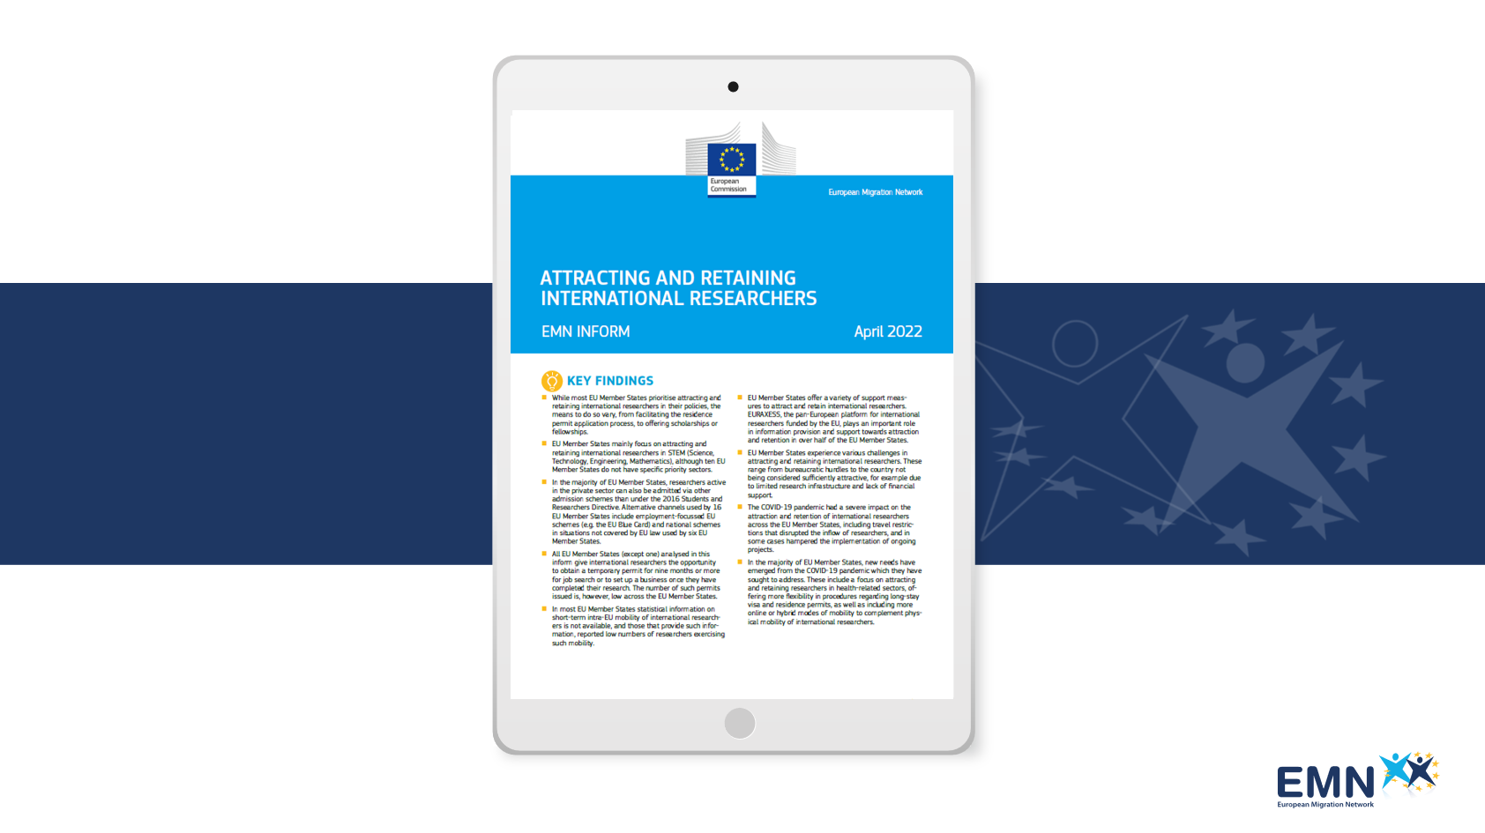
Alt text: Heading of EMN inform on attracting and retaining international researchers
Tags: @EUHomeAffairs

New publication: 📘 EMN inform on attracting and retaining international researchers.

Third-country researchers from non-EU countries can provide important expertise to European universities and other research institutions, promoting knowledge circulation across the EU. This new EMN inform explores challenges and good practices adopted by Member States to welcome and retain international researchers, also analysing the implementation of relevant EU-level and national policies, schemes and practices.

Now available in the EMN informs web page ➡ https://ec.europa.eu/home-affairs/networks/european-migration-network-emn/emn-publications/informs_en

Visual element :
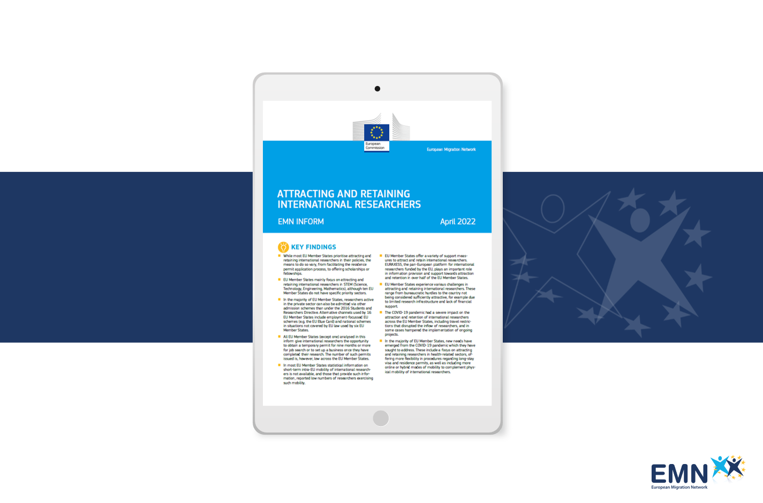

REMINDER
Twitter
Attracting and retaining international researchers: latest EMN inform provides a comparative overview of Member States’ approaches, challenges, and best practices.
Available in the EMN informs web page ➡ https://ec.europa.eu/home-affairs/networks/european-migration-network-emn/emn-publications/informs_en

#EMNMigration

How do Member States attract and retain international researchers? The latest 📘EMN inform maps approaches, experiences and challenges at national and EU level:

✔ Most EU Member States prioritise attracting and retaining international researchers in their policies.

✔ A variety of support measures are in place, including support on arrival, fast-track applications and financial facilitation.

✔ The COVID-19 pandemic had a severe impact on the attraction and retention of international researchers across the EU Member States, including travel restrictions that disrupted the inflow of researchers, and in some cases hampered the implementation of ongoing projects.

✔ In order to address the new needs and issues, new measures have been implemented, such as the introduction of online or hybrid modes of mobility to complement physical mobility.

Available in the EMN informs web page ➡ https://ec.europa.eu/home-affairs/networks/european-migration-network-emn/emn-publications/informs_en

#EMNMigration

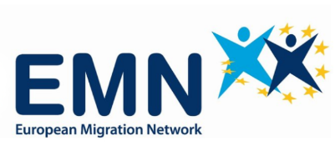
GLOSSARY TWEET
Twitter
Latest EMN inform focuses on Member States measures to attract and retain international researchers.
But how is a “researcher” defined in the EU migration context? Check out this #EMNMigration definition. (1/3)
For more definitions download the Glossary app.
Available both on Android and iOS. #EMNMigration
To download the app:
Android: https://play.google.com/store/apps/details?id=it.ittigcnr.emnglossary (2/3)
iOS: https://apps.apple.com/us/app/emn-glossary/id1464780389 (3/3)
Visual element:
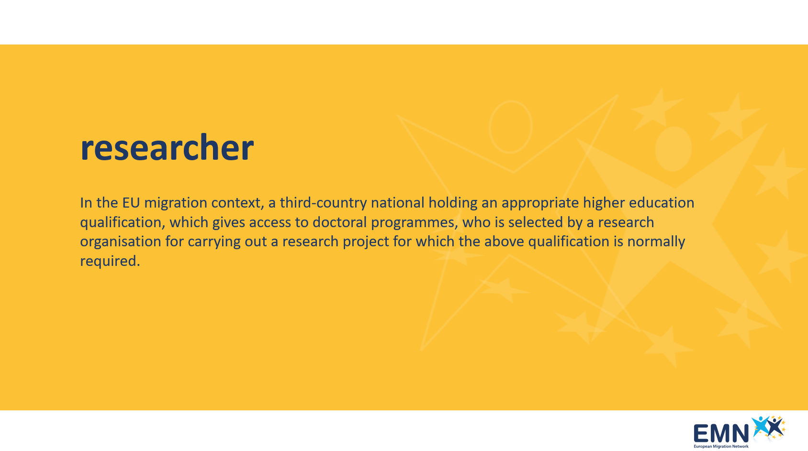

The latest EMN inform focuses on measures adopted by EU Member States to attract and retain international researchers, aiming to map experiences and approaches, as well as the latest challenges.
While most EU Member States prioritise attracting and retaining international researchers in their policies, the means to do so vary, from facilitating the residence permit application process, to offering scholarships or fellowships.

But how is a “researcher” defined in the EU migration context?

Read the definition from the EMN Glossary app.
In the comments:
1)
The EMN Glossary is an online resource of terms related to migration and asylum in Europe.
For more definitions download the Glossary app, available both on Android and iOS.
To download the app:
Android: https://play.google.com/store/apps/details?id=it.ittigcnr.emnglossary
2)
iOS: https://apps.apple.com/us/app/emn-glossary/id1464780389
Visual Element:
