LAUNCH
Twitter
Just published: EMN inform on secondary movements of beneficiaries of international protection.
Available here ➡ https://home-affairs.ec.europa.eu/news/new-emn-inform-secondary-movements-beneficiaries-international-protection-2022-07-25_en

#EMNMigration

Visual element:
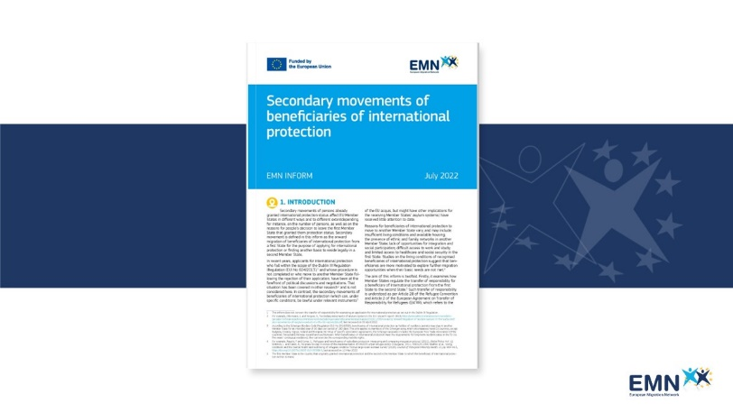

Just published: 📘 EMN inform on secondary movements of beneficiaries of international protection.

The aim of this inform is to examine how Member States have regulated the transfer of responsibility for a beneficiary of international protection from the first State to a second State. It also explores the situation where beneficiaries of international protection, already recognised in a first State, lodge applications for international protection in a second State.

Read more about it here ➡ https://home-affairs.ec.europa.eu/news/new-emn-inform-secondary-movements-beneficiaries-international-protection-2022-07-25_en

#EMNMigration

Visual element:
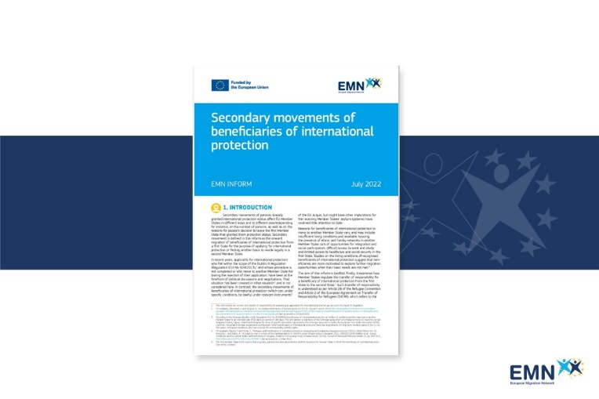

REMINDER
Twitter

Secondary movements of beneficiaries of international protection

➡ Latest EMN inform focuses on how Member States regulate the mobility and residence of persons already granted international protection status in another Member State.

Available here: https://home-affairs.ec.europa.eu/news/new-emn-inform-secondary-movements-beneficiaries-international-protection-2022-07-25_en

#EMNMigration

Visual Element: Quote Launch post

🔹 How do Member States regulate the mobility and residence of persons already granted international protection status in another Member State?
🔹 What are the appliable rules for transfer of responsibility of a beneficiary of international protection?
Under the current EU law, beneficiaries of international protection can travel and reside within the Union. Beneficiaries can also move to a second State to make a further application for international protection, however, in this case, the EU law does not regulate the transfer of responsibility.
Member States address the situation by applying different legal bases including the European Agreement on Transfer of Responsibility for Refugees (EATRR), national legislation and/or bilateral agreements. This fragmentation of the legal and policy framework can negatively impact applicants, as different regulations and practices apply at national level.

Read more in our new report ➡ https://home-affairs.ec.europa.eu/news/new-emn-inform-secondary-movements-beneficiaries-international-protection-2022-07-25_en

#EMNMigration

Visual Element: Quote Launch post

GLOSSARY
Twitter
This EMN inform examines two situations related to secondary movements: the transfer of responsibility of international protection and the applications lodged in a second State by beneficiaries already protected in a first State.

What are “secondary movements of migrants”? ⬇

#EMNMigration

In the comments:
For more #EMNwords definitions download the Glossary app.
Available both on Android and iOS. To download the app:
Android:https://play.google.com/store/apps/details?id=it.ittigcnr.emnglossay
iOS: https://apps.apple.com/us/app/emn-glossary/id1464780389

Visual Element:
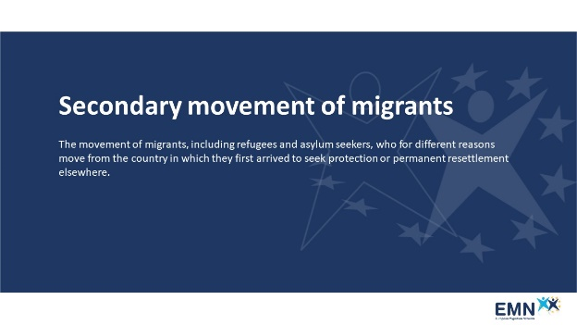

The latest EMN inform examines two specific situations concerning secondary movements, namely the transfer of responsibility of international protection and the applications for international protection lodged in a second State by beneficiaries already protected in a first State.

What is meant by “secondary movements of migrants”? Read the definition from the EMN Glossary app.

#EMNMigration

In the comments:
1)The EMN Glossary is an online resource of terms related to migration and asylum in Europe.
For more definitions download the Glossary app, available both on Android and iOS.
To download the app:
Android: https://play.google.com/store/apps/details?id=it.ittigcnr.emnglossary
2) iOS: https://apps.apple.com/us/app/emn-glossary/id1464780389

Visual Element:
