LAUNCH
Twitter
Just published: EMN inform on secondary movements of beneficiaries of international protection
Available here ➡ https://home-affairs.ec.europa.eu/news/new-emn-inform-secondary-movements-beneficiaries-international-protection-2022-07-25_en

#EMNMigration

Visual element:
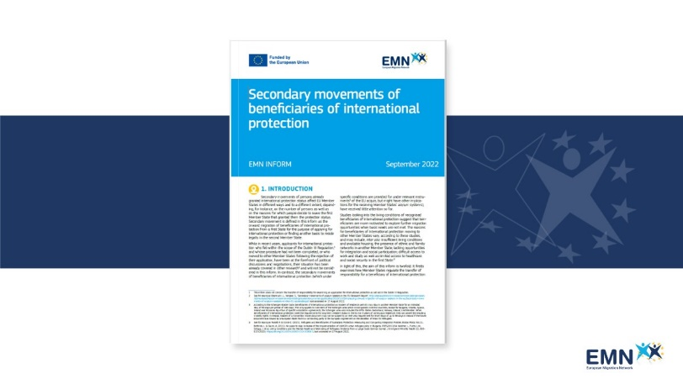

Just published: 📘 EMN inform on secondary movements of beneficiaries of international protection

The aim of this inform is to examine how Member States have regulated the transfer of responsibility for a beneficiary of international protection from the first State to a second State. It also explores the situation where beneficiaries of international protection, already recognised in a first State, lodge applications for international protection in a second State.

Read more about it here ➡ https://home-affairs.ec.europa.eu/news/new-emn-inform-secondary-movements-beneficiaries-international-protection-2022-07-25_en

#EMNMigration

Visual element:
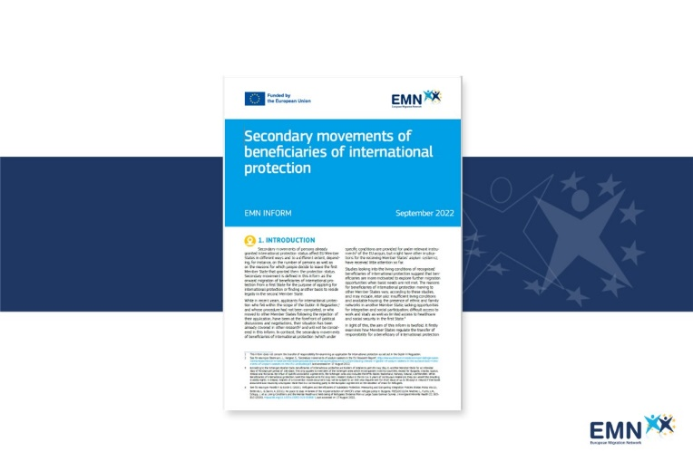

REMINDER
Twitter

Secondary movements of beneficiaries of international protection

➡ Latest EMN inform focuses on how Member States regulate the mobility and residence of persons already granted international protection status in another Member State.

Available here: https://home-affairs.ec.europa.eu/news/new-emn-inform-secondary-movements-beneficiaries-international-protection-2022-07-25_en

#EMNMigration

Visual Element: Quote Launch post

🔹 How do Member States regulate the mobility and residence of persons already granted international protection status in another Member State?
🔹 What are the appliable rules for transfer of responsibility of a beneficiary of international protection?

Under the current EU and international legal framework, several options exist for beneficiaries of international protection to travel and reside in another Member State, including short-term forms of mobility under the Schengen Borders Code, intra-EU mobility based on the Directive 2003/109/EC (‘Long-Term Residence’ Directive).

However, EU law does not regulate the transfer of responsibility for beneficiaries of international protection. Consequently, at national level, Member States apply different legal bases, including EATTR, national legislation and bilateral agreements.

Read more in our new report ➡ https://home-affairs.ec.europa.eu/news/new-emn-inform-secondary-movements-beneficiaries-international-protection-2022-07-25_en

#EMNMigration

Visual Element: Quote Launch post

GLOSSARY
Twitter

The latest EMN inform explains that the main challenge encountered by Member States related to secondary movements is the lack of a uniform legal base to address all applications

What are “secondary movements of migrants”? ⬇

#EMNMigration

In the comments:
For more #EMNwords definitions download the Glossary app.
Available both on Android and iOS. To download the app:
Android:https://play.google.com/store/apps/details?id=it.ittigcnr.emnglossay
iOS: https://apps.apple.com/us/app/emn-glossary/id1464780389

Visual Element:
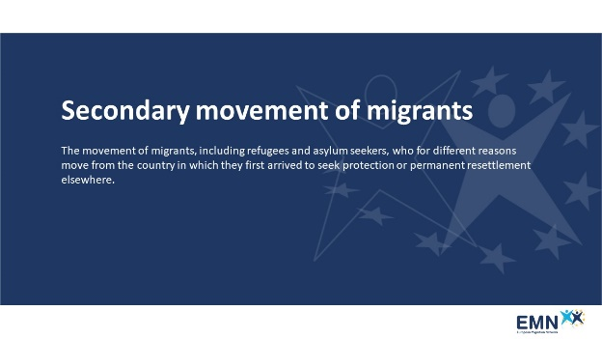

The latest EMN inform on secondary movements of beneficiaries of international protection explains that the main challenge encountered by Member States is the lack of a uniform legal base to address all applications.

But what is meant by “secondary movements of migrants”? Read the definition from the EMN Glossary app. ⬇

#EMNMigration

In the comments:
1)The EMN Glossary is an online resource of terms related to migration and asylum in Europe.
For more definitions download the Glossary app, available both on Android and iOS.
To download the app:
Android: https://play.google.com/store/apps/details?id=it.ittigcnr.emnglossary
2) iOS: https://apps.apple.com/us/app/emn-glossary/id1464780389

Visual Element:
